

CBL Cocos (pvt)ltd

Prepared for CBL Cocos(Pvt)Ltd

By Nexsoft

Project Development Phases

**Introduction**

Nex Computer provides full range of computer accessory and internet marketing services to various businesses in Sri Lanka for over 10 years. **NexSoft** is a subsidiary of Nex Computer. Our experience helps to define the best online strategy to serve your marketing and sales requirement.

We always split projects in phases and would like to offer the same approach for your company as well. We'd like to offer the following phases and activities for your project:

1. Phase 1- Create a web application
2. Phase 2 - Define a content development strategy

Please take a look at our proposal and don't hesitate to contact me if you have any questions.

Phase 1: Web Application

First priority is to establish a basic web presence through the creation of a web application.

Phase 2: Content

* 1. **Add Supplier**

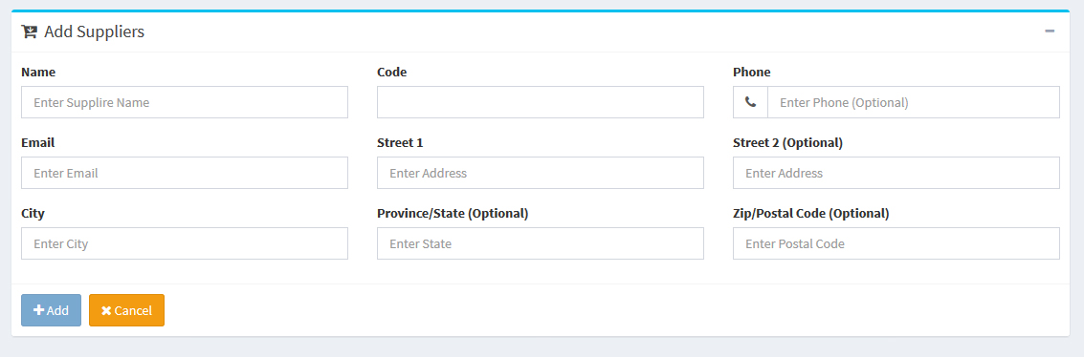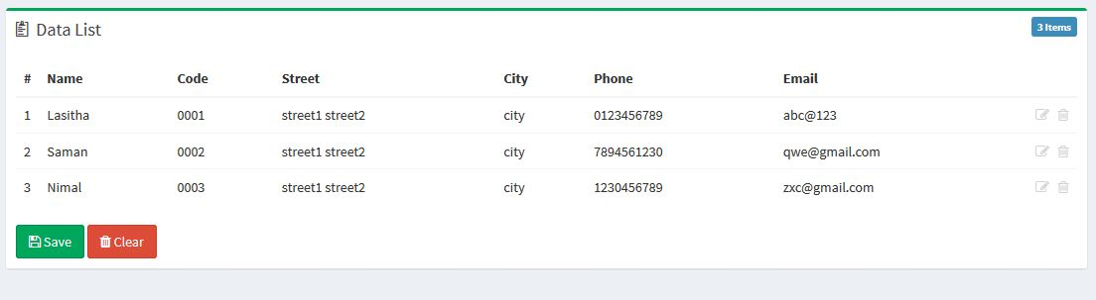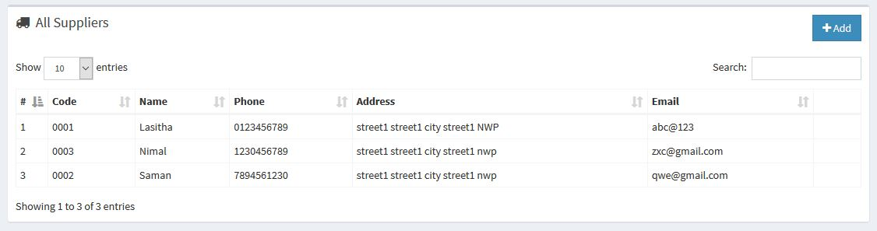

* 1. **Add Contracts**

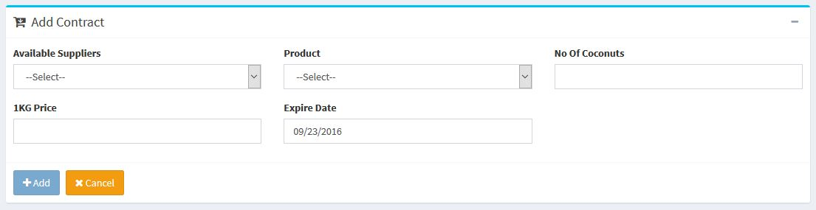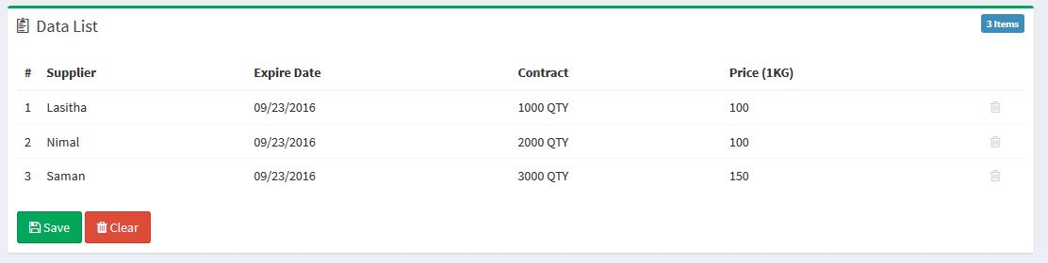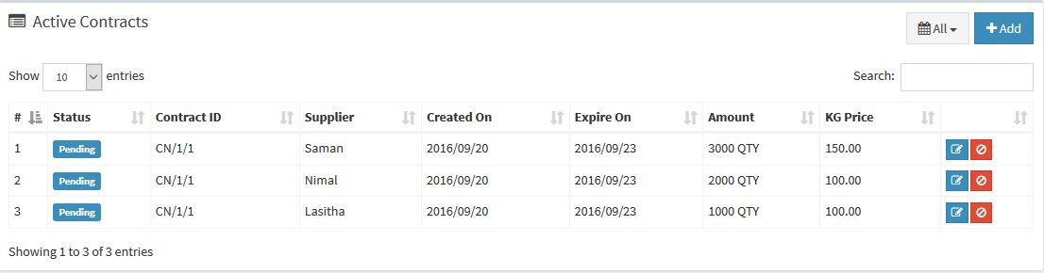

1. **Goods Receiving**

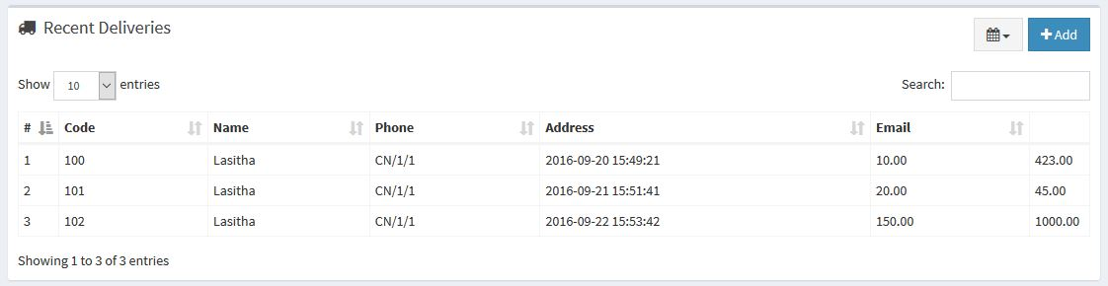

1. **Research and planning**

* Requirement gathering.
* Project planning.

1. **Solution Design**

* Sitemap
* Wireframes
* User workflows
* Functional specification

1. **Design**

* Initial home page look and feel

1. **Front end development**

* 5x templates build html5/css
* Java script and ajax
* Jquery
* AngularJS
* Cross browser fixes

1. **Back end development**

* Configuration setup
* Php and mysql
* Admin panel

1. **Testing**

* Internal functional testing
* Client user acceptance testing(UAT)

1. **Go live**

* Live server setup

**Notes**

**Estimate Only**

This document is an estimate only and does not represent a binding agreement between the Client and Nexsoft. A contract will be provided upon acceptance of this estimate.

**Updates**

This estimate covers design and construction of the system through the launch phase.

**Additional Cost Allowances**

Additional services or alterations outside the scope of the contract will be quoted as needed.

Web Application Estimate

**Estimate**

Initial fee: Rs.50, 000/= (Web application)

Server charges, domain charges does not include here.

**Typically, these are the days between and including Tuesday to Saturday and do not include public holidays and Sunday and Monday.

________________________    ______________

Manager Date

Thank You for your Business!